**cia-1**

**CSE 2 year**

**Operating System(RCS-401)**

**Date:** 10th May 2020

|  |  |
| --- | --- |
| **Course Outcomes** | |
| C216.1 | Understand the structure and functions of OS |
| C216.2 | Learn about Processes, Threads and Scheduling algorithms |
| C216.3 | Understand the principles of concurrency and Deadlocks |
| C216.4 | Learn various memory management scheme |
| C216.5 | Study I/O management and File systems. |

**Section A**

**Answer all the following question**

**4**

**Q1).** What is Queue?

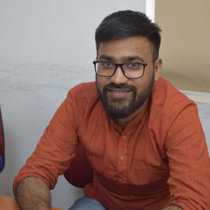

**Q2).** What is Binary Tree?



**Section B**

**Answer any 2 questions**

**8**

**Q1).** Is it possible to have a solution for Dijkstra’s “Dining Philosophers” Problem,that ensures, under all possible conditions:-(a)That no philosopher ever faces condition of “Starvation”AND(b)The solution meets the requirement of “Progress”

**Q2).** What is DQueue?

**Q3).** Show how SEMPHORES can be used to achieve the precedence of the following graph? Answer the following questions:-(a)At least how many Semaphores will be required? GiveJustification for your answer.(b)What will be the initial Count of each semaphore?(c)What will be the advantage of using “Counting Semaphores”rather than “Binary Semaphores”?(d)Can “Condition” variables be used to provide the same solution?

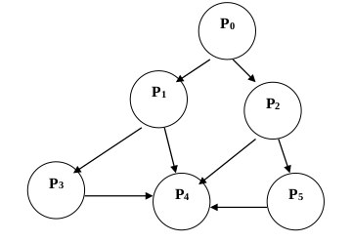

**Section C**

**Answer any 3 questions**

**18**

**Q1).** Suppose a system is using SJF algorithm for CPU scheduling and it predicts next CPU burst using exponential average of the previous CPU bursts. If the first prediction of CPU burst T 0 = 20 ms, weight factor  = 0.6, and the previous CPU burst are 08, 16, 24, 16 ms in that sequence. Predict the next CPU burst.

**Q2).** What is Tree?

**Q3).** For the following snap-shots of processes, use bankers algorithm to determine:- (a) Need Matrix? (b) Whether the system is in a safe state? (c) What is safe sequence?

**Q4).** With reference to the following set of Processes/Jobs, determine Average Waiting Time & Average Turnaround Time, using following scheduling algorithms